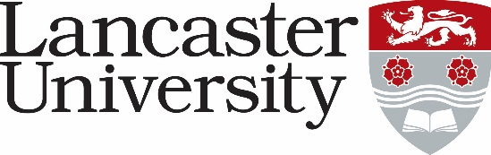

**JOB DESCRIPTION**

Recruitment, Conversion and Marketing Coordinator

**Vacancy Ref:**

|  |  |
| --- | --- |
| **Job Title:** Recruitment, Conversion and Marketing Coordinator | **Present Grade:** 5 |
| **Department/College:** | |
| **Directly responsible to:** Student Recruitment & Conversion Officer | |
| **Supervisory responsibility for:** Student ambassador team | |
| **Other contacts** | |
| **Internal:** Department undergraduate (UG) and postgraduate (PG) admissions leads (where applicable); Heads of Department; all academic and support staff in departments, student recruitment and outreach officer; student ambassadors; colleagues in central and faculty marketing and recruitment team; schools’ liaison representatives; careers service | |
| **External:**  Prospective students, parents/guardians, advertising agencies, schools and service providers for outreach activities, representatives of external suppliers, and contacts in other HEIs. | |
| **Major Duties:**  To provide a high standard of administrative support for all aspects of a departments student recruitment, conversion and marketing activity. Duties will include:   * Support the Department in developing creative and cost effective activities and projects to raise the profile and encourage students to apply for and study courses at Lancaster University. * Under the direction of the UG Recruitment Director and line manager, develop a programme of activities and events to facilitate the recruitment of students as prioritised by the department. * Liaising with departmental colleagues in the organisation of departmental offer holder events and the contribution to University-wide open days. * Liaise and build strong sustainable links with key school contacts, teachers, departmental and wider university colleagues to raise awareness of courses and subject. * To provide support for in-house recruitment events ensuring all logistical arrangements, including room and accommodation bookings, hospitality and travel arrangements are in place. Liaising with the Department safety officer to ensure safety/insurance related issues are in place. * To provide accurate information, advice and guidance to prospective students about courses and the UCAS process. * Support external recruitment activities at schools, other external organisations and HE recruitment events. This includes attending the event(s) if required. * To support the departmental website and social media sites within the Department and ensure they are updated at regular intervals liaising with Faculty support as required. * To act as secretary for any relevant committees, working closely with the Chair to ensure the effective running of the committee and the follow up of agreed actions. * Collate, organise and prepare suitable material to be used in Departmental recruitment/marketing including print and digital, working closely with relevant academic staff; coordinate and review departmental literature, including monitoring its use and impact, and develop strategies for improvement. * Liaise with artwork designers, photographers and printers as required to ensure high quality publications are produced. * Managing any associated student staff, relating to recruitment activities. * Exploring opportunities to apply for funding to support marketing and recruitment activities. * Any other duties appropriate to the role, as required by the line manager. | |