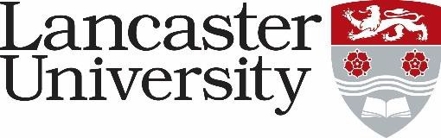

JOB DESCRIPTION
Marketing Coordinator – Faculty, External Relations
Vacancy Ref:

Job Title: Marketing Coordinator (Faculty) | Present Grade: 5S
Department/College: Health and Medicine
Directly responsible to: Faculty Marketing Manager
Supervisory responsibility for: n/a
Other contacts
Internal: Central administrative staff, Senior Management Team, ISS and Library staff, faculty and departmental staff
External: External agencies, suppliers and providers, other institutions and organisations as appropriate
Major Duties:
To provide a high level of administrative support for all aspects of the Faculty of Health and Medicine’s marketing communications activity. Duties will include:

Marketing Campaigns
- Coordinate and review the development of marketing content for student recruitment campaigns.
- Develop content and manage the running of email campaigns including creating new email templates and written copy, data management to ensure effective segmentation and targeting, and reporting on results.
- Carry out desk research to inform data driven campaign planning.
- Input into agency management, purchase order requests, production of internal documents (presentations, reports, as requested).

Marketing Content
- Undertake planning and preparation of digital marketing collateral (including but not limited to video and photography).
- Coordinate the development and implementation of a media library in conjunction with colleagues from across the University and maintain content within the media library.
- Create and develop engaging and lively course and student recruitment content for the prospectuses, website, and email campaigns including copywriting.
- Work with colleagues across the University to gather student generated content to support campaigns.
- Creating compelling copy for the core University website and other digital channels, ensuring an optimal user experience. There will be opportunity to assess existing content and to regularly write new copy.
- Working with the colleagues to update course marketing content on the University website, including the updating of module content on course web pages.
- Develop creative and compelling content for a range of social media channels in line with the social media strategy.
- Build, write copy and gather content for engaging email communications in our customer
relationship management platforms.

Undertake any other tasks required.

This post will require you to work during the clearing and confirmation period – usually the latter end of August around A level results day. Leave during this period will be restricted.

