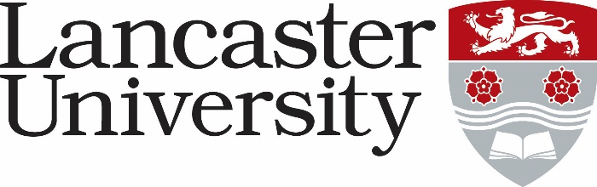
JOB DESCRIPTION

Job Title: Research Associate | Present Grade: 7
Department/College: School of Engineering (SoE)
Directly responsible to: Dr Basu Saha
Supervisory responsibility for: Undergraduate & postgraduate students working on the same/related projects
Other contacts
Professor Mamdouh Gadalla, Port Said University, Egypt, and The British University in Egypt (BUE) and his research team based in Egypt
Technical staff in the School of Engineering
Major Duties:

Your role will be to develop a strategic guideline for waste cooking oil (WCO) quality assurance in collaboration with academic and industrial partners in Egypt. The work will include the development of a rapid testing method to assess the quality of the produced WCO. The project will support the three dimensions of the United Nations Sustainable Development Goals (SDGs) of Egypt vision 2030 including economic, social, and environmental dimensions. You will attend regular project meetings to present your results and be involved in discussions regarding the next steps of the project implementation, along with international collaborators. The main duties are listed below:

- Development of a rapid testing method for quality assurance of WCO and determination of physical and chemical changes that occurred in WCO due to the repeated use and consumption of cooking oil.
- Exploring the plausible route for the production of highly stable biodiesel and valorisation of glycerol for cost-effective conversion of WCO.
- Developing a comprehensive guideline for effective WCO management in Egypt in collaboration with the project partners.
- Assisting in the day-to-day management and coordination of the project.
- Assisting in organising a workshop during the duration of the project.
- Attending regular progress meetings and discussing the project with the collaborators.
- Writing progress reports and presenting experimental results in the project meetings.
- Actively produce and sustain publications output in the area of specialism in the form of high-quality refereed journals, refereed and non-refereed conference papers, chapters in books and contribute to the REF assessment.
- Participation in national and international conferences and workshops to present the results of the project to a wider audience and to learn about current advances in the field.
- Willingness to visit and collaborate with the project partners in Egypt.
- Assisting undergraduate projects, Masters, and PhD students.
- Participation in (and ultimately taking the lead in) writing new research proposals that build on the expertise in high-quality biodiesel production and valorisation of glycerol that will be developed in this project.
- Depending on project requirements, you may also need to work in other areas, requiring a high degree of flexibility, self-motivation, and the ability to acquire new knowledge.
- To carry out specific other duties as may be reasonably requested by the project leader and that is commensurate with the nature and grade of the post.

